**WELCOME**

**

**our lovely**

**Confirmation families.**

**Please stay for a cuppa afterwards!**

**AUCTION COMING UP! WE STILL NEED AS MANY ITEMS AS POSSIBLE PLEASE! DATE FOR YOUR DIARY!***

***Save the date! Saturday the 14th of October.***

Join us on for fun at the auction, complimentary teas and coffees and a chance to socialise with your neighbours and fellow parishoners

We are still collecting Items to be auctioned please!

*PLEASE CONTACT AIDEEN ON* ***0868182241*** *OR THE PARISH OFFICE IF YOU HAVE SOMETHING YOU FEEL WOULD SUIT. COLLECTION CAN BE ARRANGED.*

**AUCTION COMING UP! WE STILL NEED AS MANY ITEMS AS POSSIBLE PLEASE! DATE FOR YOUR DIARY!***

***Save the date! Saturday the 14th of October.*** We will have a full day’s viewing on the Saturday with the auction itself on Saturday evening. Further details to come. Collecting of items is going full steam ahead now! Here are some examples of what we will take. Glassware, silverware, candles, ornaments, vouchers for everything and anything, antiques, designer clothes (good as new) jewellery

.Just about anything as long as its *new or good as new.*A big thank you to those who have already donated but we need lots more

*PLEASE CONTACT AIDEEN ON* ***0868182241*** *OR THE PARISH OFFICE IF YOU HAVE SOMETHING YOU FEEL WOULD SUIT. COLLECTION CAN BE ARRANGED.*

**COMMUNITY PRAYER SERVICE**

Please join us for prayer coffee and chat this Wednesday morning 4th October in **St Mary’s at** **10 am.** We will be joined by our friends from Powerscourt parish. We look forward to seeing as many of you as possible.

The theme is “***A thanksgiving Reflection”***

**REQUEST**

Would anyone out there know a jeweller who could do a valuation on one piece for our auction please? 

**LOOK AFTER OUR WORLD- GREEN TIP**

In an era where technology is rapidly advancing, it’s becoming increasingly important to consider sustainable alternatives to traditional printed materials. Opting for digital media and e-books not only provides convenience and accessibility but also reduces the environmental impact associated with paper production and waste. 

Go for a kindle this year!

**THIS WEEK’ S STORY- THE SCORPIAN**

##### **There was a man who saw a scorpion floundering around in the water. He decided to save it by stretching out his finger, but the scorpion stung him. The man still tried to get the scorpion out of the water, but the scorpion stung him again.**

A man nearby told him to stop trying to save the scorpion that kept stinging him.

But the man said: "It is the nature of the scorpion to sting. It is my nature to love. Why should I give up my nature to love just because it is the nature of the scorpion to sting?"

Don't give up loving. Don't give up your goodness. Even if people around you sting sometimes.



***Please Read*** the parish link and take it

home with you. Leave it Loitering with intent,

and spread the word about upcoming events,

trainings and new groups

### **BOOK REVIEW Hope in the Valley** by **Mitali Perkins.**

AGE 11-13

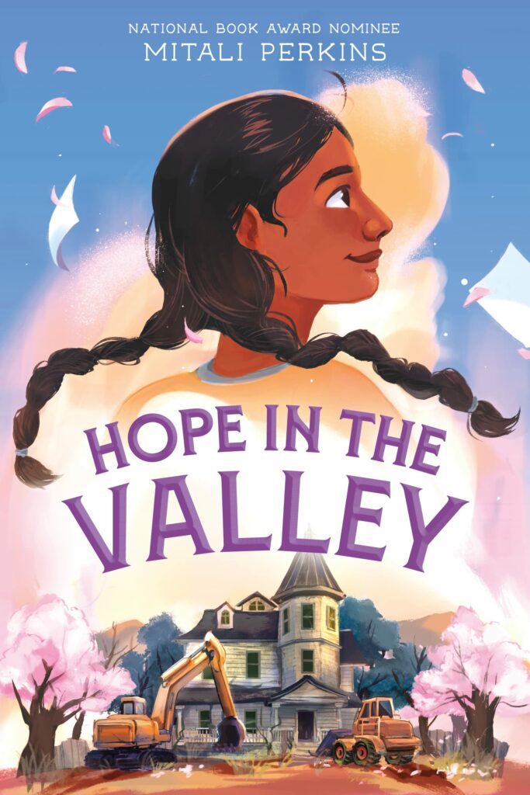Pandita Paul is adamantly against change: whether it’s the city demolishing the lovely, abandoned property next door or her widowed father *gasp* starting to date. As the story opens, Pandita is turning 13 and looking forward to summer. School is done, and it will be easier to avoid her former best friend. Time to enjoy her secret spot in the abandoned neighbouring mansion, compose poetry, and try not to forget her mother’s memory.

That is Pandita’s plan. Her family has other ideas, and she finds herself signed up for music camp. As if that weren’t bad enough, the city is planning on destroying the neighbouring mansion and building —well, it depends on who you ask. Determined to hide her singing voice and stay under the radar, Pandita finds herself drawn into her local community, digging into local history (actually enjoying music camp!) and finding a new friend. Could change actually be a good thing? Could it help her as she grieves and processes her late mother’s life and legacy?

Taking place in 1980, Hope in the Valley feels like a teless tale. Mitali Perkin’s captures the warmth of family as Pandita’s father and sisters support and challenge her to grow. Friendship is also portrayed beautifully, from making a new friend to navigating former friendships and cross-generational friendship.

Friday 29th September with a trip to the Botanic Gardens to see the 'Sculpture in Context'



**PARISH LINK 30th Sept/1st Oct Website: Enniskerryparish.ie**

**Welcome to our celebration of the Eucharist.**

**Welcome to our celebration of the Eucharist this weekend!**

**KILMACANOGUE**

Kilmacanogue History Society first Talk of the Season will be on Monday 2nd October in the Kilmacanogue Parish Hall @ 8p.m. All welcome. We are delighted to have Mr. Felix Larkin Historian and writer as our Speaker and we can expect an excellent and interesting Talk on the subject of **JFK: 60 years after Dallas.** Those of us of a certain age can recall exactly where we were and what we were doing when we heard about the assassination of President Kennedy 60 years ago. Such was the impact of that event. Our Speaker will address the question of just how good a President he was despite the tragedy of his early death and later romanticisation of his Presidency as ‘Camelot on the Potomac.’

……………………………………………………..

 Kilmacanogue National School opens enrolment for Junior Infants for September 2024 on Monday October 2nd.  Please contact school office at 2861934 for further information.

**DOING OUR BIT!**

Would you like to be part of a little group that would assess our parish green-ness! We would like to do our little bit by being as green as possible. This is a chance to invite your children or grandchildren to get involved. Please contact me for further details on what this would involve 086 8182241.

**Ministry**

Please join us on ***Tuesday evenings at 7 30*** in St Mary’s church if you would like the opportunity to sing and fill in from time to time when are regular musicians are not available. See you there!

**Thought for** 

**the week!**

“True glory lies in rising every time you stumble and fall.”

Nelson Mandela

**Prayers Please…**

Feeling alone and scared all around our world right now

**This weekend’s intentions –30th September/1st October**

St Mary’s 6pm: Robert Kavanagh (17th A)

St. Mary’s 11am: Meet and Greet Mass- Confirmation

St Mochonog’s 10am: Meet and Greet Mass- Confirmation

Jobie Stephens (Months Mind)

St. Patrick’s 10am: Meet and Greet Mass- Confirmation

**Next week’s intentions 7th/8th October**

St. Mary’s 6pm: Edward Lalor (A)

St Mary’s 11am: Ann Coffey (A) Betty Kenna (A)

**

what is it?

The Season of Creation begins on September 1, World Day of Prayer for the Care of Creation, and ends on October 4, the feast of St. Francis of Assisi, the patron saint of ecology beloved by many Christian denominations.

Individuals and communities are invited to participate through prayer, sustainability projects and advocacy.

Check out the Laudato si movement on line https://laudatosimovement.org/what-we-do/

**A WORD FROM POPE FRANCIS ……. LAST WEEK**

Human justice says to “give to each his own according to what he 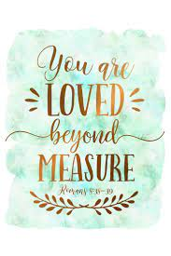deserves”, while God's justice does not measure love on the scales of our returns, our performance or our failures: God just loves us, He loves us because we are his children, and He does so with an unconditional love, a freely-given love.

Brothers and sisters, sometimes we risk having a “mercantile” relationship with God, focusing more on our prowess than on the [generosity](https://www.popefrancishomilies.com/generosity) of his grace. Sometimes even as the Church, instead of going out at all hours of the day and extending our arms to all, we can feel like the first in our class, judging others far away, without thinking that God loves them too with the same love He has for us. And even in our relationships, which are the fabric of society, the justice we practise sometimes fails to break out of the cage of calculation, and we limit ourselves to giving according to what we receive, without daring to go the extra mile, without counting on the effectiveness of good done freely and love offered with a broad heart. Brothers, sisters, let us ask ourselves: do I, a Christian, know how to go out towards others? Am I generous towards everyone, do I know how to give that extra understanding and forgiveness, as Jesus has done and does every day with me?

May Our Lady help us to convert to God's measure: that of a love without measure.

**Pope Francis**