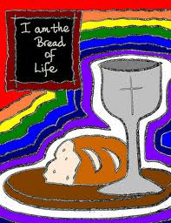

A Journey of Remembering and looking forward

October
Sunday 23rd Short service to celebrate love

November
Sunday 20th Preparation Mass

December
Advent On line resources

January
Family gathering Looking forward with love

February/ March
Love Life Live Lent (on line)

April
Sunday 2nd Preparation mass

